William Harvey  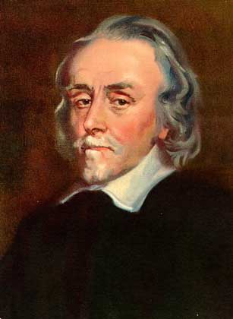  1578-1657 | - English physician  - Disproved many of Galen’s hypotheses (worked with apes and dogs in the 2nd century) Ex: the liver digested food and processed it into blood  - From direct observations of humans, Harvey concluded that blood circulated throughout the body, pumped by the heart and returning through the veins; valves maintained a one way flow
Johannes Kepler  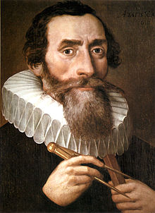  1571-1630 | - German astronomer and mathematician; assistant to Brahe  - Used Brahe’s data to formulate laws to describe planetary motion.  - Mathematically proved the heliocentric theory (the Sun is at the center of the universe, with all the planets and stars revolving around it)  - Proved that planets revolved around the sun in elliptical (oval) orbits rather than circles and demonstrated the planets move fastest when they are closest to the Sun
Rene Descartes  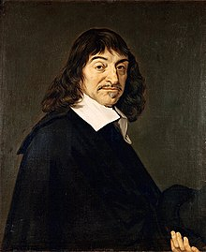  1596-1650 | - French philosopher and mathematician  - Believed that scientists needed to reject old assumptions  - Knowledge should be gained by using mathematics and logic, rather than experimentation  - Everything should be doubted unless proved by reason; wrote Discourse on Method  - The one thing he knew was true was the he existed; “I think, therefore I am.”  - Developed analytic geometry; algebraic procedures are applied to geometry
Andreas Vesalius  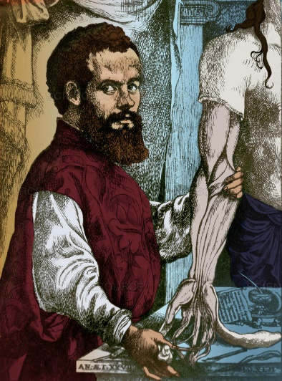  1514-1564 | - Flemish anatomist and surgeon  - Considered father of modern anatomy  - Most of what was known about the human body was based on Galen’s work with apes and dogs in the 2nd century  - Dissecting human bodies was illegal; studying animals was the accepted method of learning about the human body  - Wrote On the Structure of the Human Body; was based on meticulous dissection of cadavers (dead bodies); to learn he often practiced on the bodies of criminals stolen from the gallows
Isaac Newton  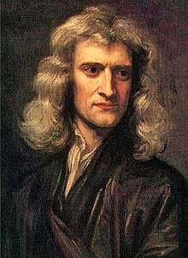  1642-1727 | - English philosopher and mathematician  - Developed the Law of Universal Gravitation; all physical objects are affected equally by the same forces, in space and on earth  - Every object in the universe attracts every other object… gravity  - Wrote The Mathematical Principles of Natural Philosophy or Principles  - Developed calculus
Galileo Galilei  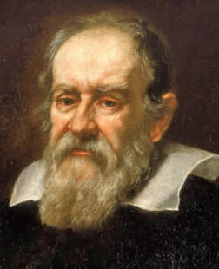  1564-1642 | - Italian astronomer and physicist  - The first to use a telescope to study the starts (1610)  - He was an outspoken supporter of Copernicus’s Heliocentric theory (the Sun was at the center of the universe, with the planets and starts revolving around it)  - His discoveries frightened the Catholic and Protestant Churches (they promoted the geocentric theory); worried that people would start to question other Church teachings  - After publishing his findings he was called to the Inquisition of Rome (1633); forced to recant his ideas and read a signed confession that admitted his ideas were false  - Lived under house arrest, but still continued to work and write, but not publish  - Official opposition to heliocentrism by the Church disappeared in 1835 when his works were finally published
Robert Boyle  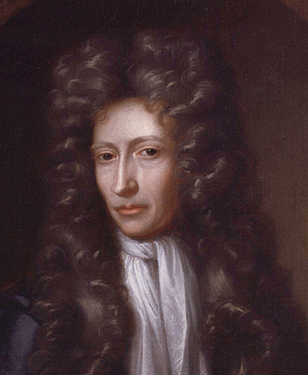  1627-1691 | - British physicist and chemist  - Regarded as a founder of modern chemistry  - Rejected the traditional theory that all matter was composed of four elements (earth, fire, water, air) in The Sceptical Chymist)  - Defined an element as a substance that cannot be reduced to other, simpler substances  - Air could not be a basic element because it was made up of a mixture of several gases  - Rejected the chemical philosophy of alchemy (base metals like lead and copper can be transformed into gold)
Francis Bacon  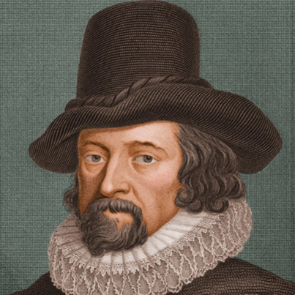  1561-1626 | - English statesman and writer  - Believed that a better understanding of the natural world will produce practical knowledge that could improve people’s lives  - Scientists relied too much on ancient theories; they should experiment! Inductive reasoning; detailed facts leading to general ideas  - Helped develop the scientific method: 1. Observe 2. Hypothesis 3. Experiment 4. Analyze data to prove or disprove the hypothesis
Nicolaus Copernicus  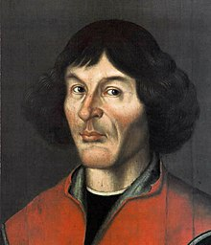  1473-1543 | - Polish astronomer  - Developed the heliocentric system (the Sun is at the center of the universe, with all the planets and starts revolving around it in circular orbits)  - Published his complete theory in De revolutionibus orbium coelestium (On the Revolutions of the Heavenly Spheres) in 1543, just before he died  - Did not want to publish his ideas because he knew that most scholars and clergy would reject his theory because it contradicted their religious views. He feared ridicule, persecution and excommunication  - De revolutionibus was on the Catholic Church’s Index of Forbidden Books from 1616 to 1835.

