WORLD GEOGRAPHY
Mr. Goodman - Room 201 paul.goodman@cobbk12.org

Mr. Goodman’s Blog: To be provided.
Textbook: Global Geography, 2018, Houghton Mifflin Harcourt Publishing Company. Books will be available for in class work and on-line.

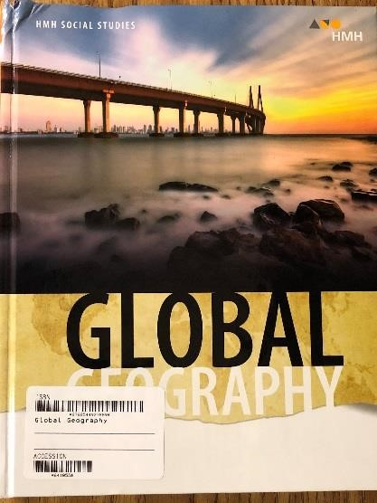
Online Access:
http://www.cobbk12.org/centraloffice/learningresources/hs.aspx#socialstudies

World Geography | Office 365 Username: firstname.lastname  Password: Same as computer password at school | HMH Georgia Global Geography

Course Description:
The world geography course provides students with an analytical view of how geographic factors have and continue to influence human behavior on the earth. Students will examine how the physical and cultural geographic factors contribute to varying levels of cooperation within the major world regions. Additionally, students will examine the importance that political, environmental, and economic factors have in a region’s development.

Content:
- Geography Skills
- United States and Canada
- Latin America
- Europe
- Russia and the Republics
- Africa
- Southwest Asia
- South Asia
- East Asia
- Southeast Asia, Oceania, and Antarctica

This sequence may change, but the students will be notified of any changes with appropriate time.

Materials: Pens and #2 pencils, college rule notebook paper, 3 ring binder, dividers for notebook, and colored pencils.

Videos:
The students will watch a limited number of videos in order to gain a better understanding of physical and political map features of the world. Some movies or documentaries may be viewed in order to gain a better understanding of different cultures around the world from a geographic perspective.

These videos may include:
- National Geographic
- Anthony Bourdain: Parts Unknown
- Anthony Bourdain: The Layover
- Man vs. Wild
- Planet Earth
- Discovery Atlas

Classroom Rules:
- The student will take responsibility for their own learning.
- Be respectful to yourself, your peers, and the teacher.
- Bring your textbook, notebook, and writing/coloring materials to class every day.
- Take notes and participate in class.
- No food or gum in class without the teacher’s permission. You may bring a drink to class, but it must have a lid or top.
- No iPods, cell phones, or electronic devices in class at any time without the teacher’s permission.
- Refrain from unnecessary talking. Please respect the right of others to learn.
- Follow all rules specified in the student handbook.

Consequences:
1st Offense- Verbal Warning
2nd Offense- Appropriate disciplinary action at teacher’s discretion. This can include detention, phone call/email home to parents or legal guardian, and/or a disciplinary referral.

Grading Policy:
Report cards will be issued every 6 weeks. Grades will be calculated by the following:

Tests 45%
Quizzes 25%
Classwork/Homework/Notebook/DBQ 20%
Final Exam 10%

Grading Scale
90-100 = A
80-89 = B
74-79 = C
70-73 = D
0-69 = F

Attendance Policy:
Please be on time to class. Any student that is late to class will have to receive a tardy pass from the Attendance Office or Tardy Station (No Exceptions).

Make-Up Policy Following Absences:
When a student is absent from school, the student has the responsibility to initiate all make-up work on the first day he/she returns to school. The student must complete the work at the teacher’s convenience.
The time allowed for completion of make-up work will be the number of days absent plus one day. (Ex. 2 days would be allowed for an absence of 1 day.)

Late Work:
Every effort should be made to turn ALL work in on time. If an assignment is turned in late, there will be a deduction of one letter grade for EACH day it is late.

Cheating/Plagiarism Policy:
Cheating/plagiarism will result in a zero (0) on the assignment and appropriate administrative action. If you do not know when, or how, to cite a source please ask the instructor before the assignment is due. A copy of the KMHS Social Studies Department Honor Code Violation form is provided and MUST be read, signed by the student and parent(s) at the bottom of the form, and returned.

Extra Help:
Extra help is available by appointment. Please let me know in advance if you would like to set up an appointment for extra help. 7:30 AM to 8:00 AM Tuesdays.

KMHS SOCIAL STUDIES DEPARTMENT
HONOR CODE VIOLATION

Student Name ___________________________________ ID#: ___________________
Student Grade (circle one) 9 10 11 12
Course: ______________________________
Date of Violation ________________

Description of Violation
_________________________________________________________________________________________ _________________________________________________________________________________________ _________________________________________________________________________________________
_________________________________________________________________________________________
__________________________________

Violation Category (please check one or more of the following):
□ | Copying another student’s work  □ This includes lab data, lab reports, homework, test answers, essays, reports, etc.
□ | Giving another student access to your work  □ This includes lab data, lab reports, homework, test answers, essays, reports, etc.
□ | Informing students of content that was present on a test when that student may be taking the test later in the day  □ This includes telling other students specific questions, general topics on which to focus additional review, chapters, homework assignments, labs, etc.
□ | Using unauthorized materials such as websites, cheat sheets, cell phones, Spark Notes, etc. not specifically approved by the teacher beforehand
□ | Completing or making a significant contribution to someone else’s assignment or allowing someone else to complete or make a significant contribution to an assignment for you
□ | Providing false information to a teacher or administrator during an inquiry related to academic integrity
□ | Plagiarism, which includes the following:  □ Copying content word for word from any source including but not limited to a website, a journal, a book, another student, etc. without giving proper citation;  □ Paraphrasing content from any source without giving proper citation of the source ▪ Plagiarism is the stealing of “thoughts” not necessarily exact words
□ | Making up data or sources that do not exist
□ | Other _________________________________________
Honor code violations will result in an administrative referral and a grade of zero for the assignment.

Student Signature__________________________________________

Parent Signature___________________________________________

This is ONLY a copy of the KMHS Honor Code Violation form. Signing this form ONLY indicates that you and your parent(s) have read and understand this form.

Confirmation: Goodman – World Geography

By signing below, the undersigned states that they have read and accept the terms and actions outlined in the syllabus.

Date __________________________________________________ Block _________________

Student Name (Print) __________________________________________________________

Student Signature _____________________________________________________________

Parent Name (Print) ___________________________________________________________

Parent Signature ______________________________________________________________

Parent Phone Number __________________________________________________________

Parent E-Mail _________________________________________________________________

